

Internal Design of The Arcade Toolbox Rendering Library

Revision 0.0
March 5, 1996
Copyright © 1996 3Dfx Interactive, Inc. All Rights Reserved

3Dfx Interactive, Inc.
415 Clyde Ave., Suite 105
Mountain View, CA 94043
Phone: (415) 934-2400
Fax: (415) 934-2425

Table Of Contents
1. Target, Design Goal and Philosophy
2. Data Flow
3. State Management
3.1 State Management API
3.2 Default State
3.2.1 Default Environment
3.2.2 Default Material
3.2.3 Default Transform
3.2.4 Default Camera
3.2.5 Default Canvas
3.2.6 Default Light
3.3 Query API
4. 3D Pipeline
4.1 Quad Set
4.2 Triangle Set
4.3 Line Set
4.4 Point Set
4.5 Immediate Quad
4.6 Immediate Triangle
4.7 Immediate Line
4.8 Immediate Point
4.9 Triangle Mesh ( a triangle strip is a degenerate triangle mesh )
4.10 Line Mesh
5. Pentium Cache Utilization
5.1 Inner Loop Data
5.1.1 The LCStoCCS Transformation
5.1.2 The CCStoVCS Transformation
5.1.3 Lighting/Culling Data
5.1.4 Clipping Data
5.1.5 State Data
5.1.6 Temporary GrVertices
5.1.7 Destination Vertices
5.2 Actual Cache Layout
6. Triangle And Quad Setup
7. Vertex Data Structures
7.1 Input Vertices
7.2 Output Vertices
8. Primitive Data Structures
8.1 Quad Set
8.2 Triangle Set
8.3 Line Set
8.4 Point Set
8.5 Triangle Mesh
8.6 Line Mesh
8.7 Immediate Quad, Triangle, Line, Point
9. Immediate Primitive Rendering
10. Texture Cache
11. Bounding Box Computation
12. Geometric Morphing Support
13. Intra-Object BSP’s
13.1 Generation
13.2 Traversal
14. Static Lighting Generation
15. Billboards
16. Material Properties and Feature Exposure

Target, Design Goal and Philosophy
The target market for this product is two fold. The first customer of this product is the internal development staff of 3Dfx and our contractors. This tool kit is intended to be a common code base for all of our internal game and technology demos. The second customer of this product is the arcade developer who hasn’t yet developed their own low level 3D rendering technology, and the game developer market at large.

By my definition, the design goal of a project is the milestone at which principle implementation stops and maintenance begins. The design philosophy is the guideline by which design decisions and compromises are made. A clear statement of both of these is fundamental to the success of any project, and this project, in all of its incarnations, has suffered from a lack of either.

The design goal of this project is poorly defined as of this writing. By current schedules, milestones are determined by a checklist on the feature set. This feature based goal may be replace by a demo based goal, where the end of primary development is marked by the completion of a set of high performance game technology demos that span the set of game genres that currently seem interesting in the market today. Broadly they are: fighting games, flying games, driving games, and indoor renderers.

The design philosophy of this project is to provide maximal feature exposure and maximal performance. Where performance is not just measure in terms of skeleton-flipping triangles per second, but real application performance.

Testing
The Arcade Toolbox Rendering Library will ship with suite of feature-specific test programs.

Lighting Modes
Tests out the various lighting modes including:
Light TypesS

Cache
Stresses the texture cache in a few different ways.

Morph

Data Flow

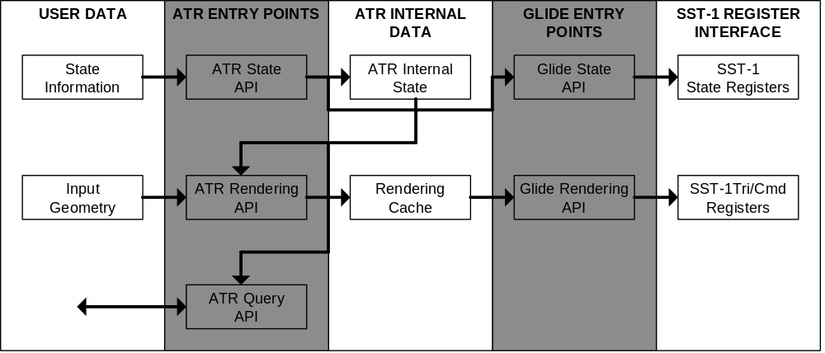

State Management

State Management API

API \ State | LCStoCCS | CCStoVCS | Per Light Cache - mat dif color * light color | Material Light Cache - mat emissive color + mat dif color * ambient lights | Glide State
Push Environment |  |  |  |  | Depth Mask  Depth Buffer Mode  Fog Table  Fog Mode  Dither Setup  AA Mode  Smooth Filter
Push Transform | Recompute
Push Material |  |  | Recompute | Recompute | Depth Mask  Alpha Blend Mode  TCM  CCM  ACM
Select Camera | Recompute
Select Canvas |  | Recompute
Add/Sub Light |  |  | Recompute | Recompute
Render |  |  |  |  | Based on multipass
Init | Create/Init | Create/Init |  |  | Init Library  Push/Select Default primitives
Shutdown | Delete | Delete |  |  | Shutdown Library

Default State

The renderer comes up in a default state after atrInit() is called. This simply assures that all of the glide state as well as the atr state is initialized to sane values.

Default Environment
The default environment enables w-buffering.

Default Material
The default material is a diffusely lit medium gray.

Default Transform
The default transform is the identity transform with no translation.

Default Camera
The default camera has an fov of 60.0 degrees, a near clipping plane of 1.0, a far clipping plane of 65000.0, and is positioned at the origin, facing down the positive Z axis.

Default Canvas
The default canvas is the size of the full screen.

Default Light
There are no default lights.

Query API
atrQueryTransform

3D Pipeline
The 3D Pipeline is described by type of primitive the library is rendering.

Quad Set
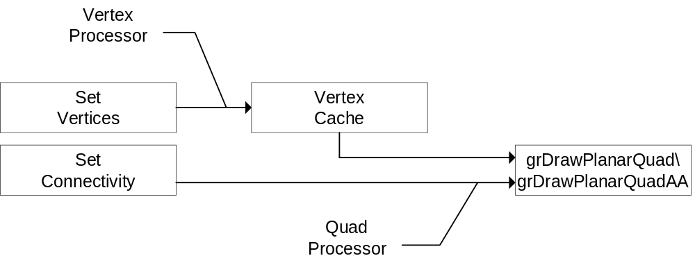

Triangle Set
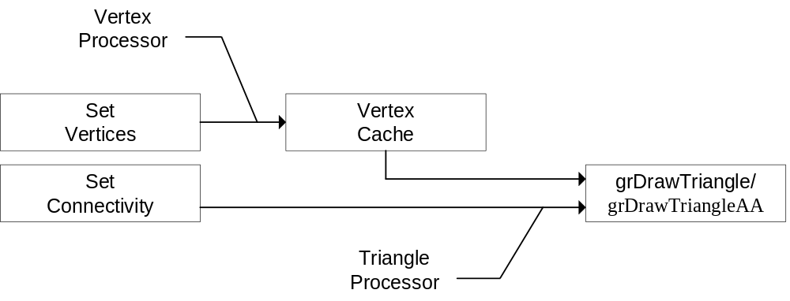

Line Set
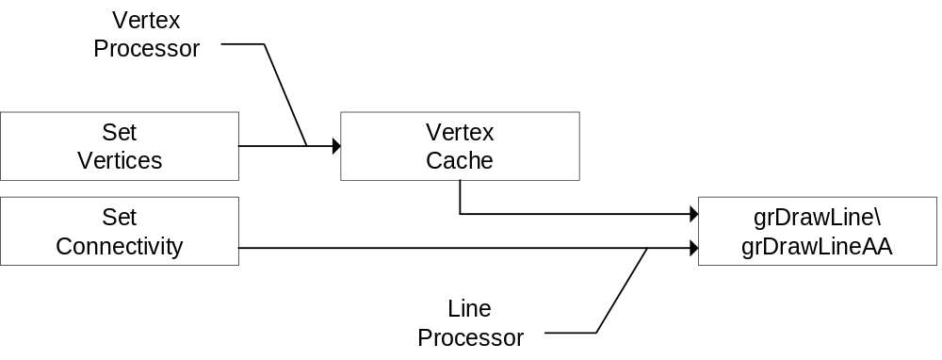

Point Set
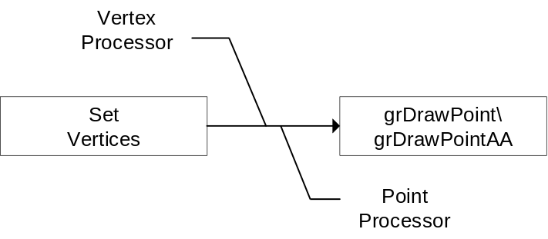

Immediate Quad
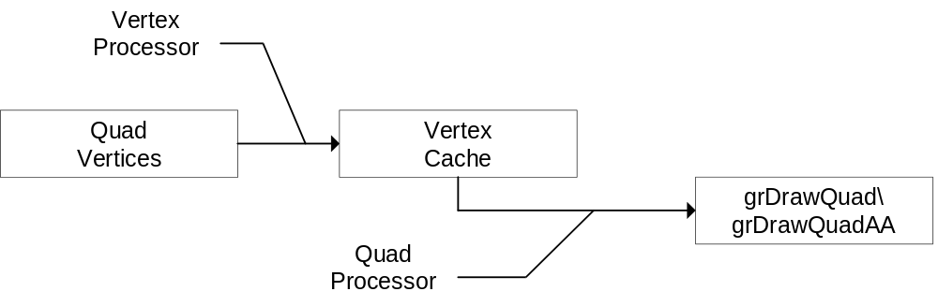

Immediate Triangle
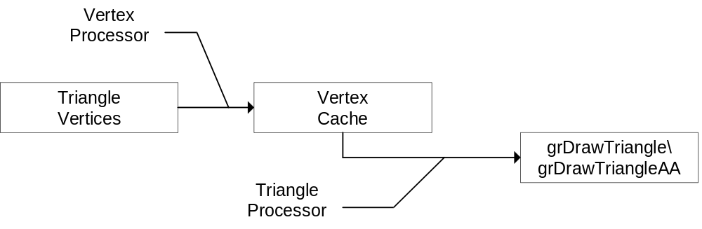

Immediate Line
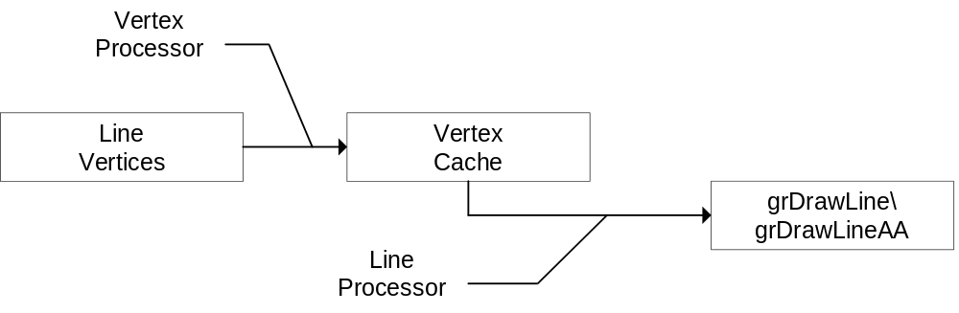

Immediate Point
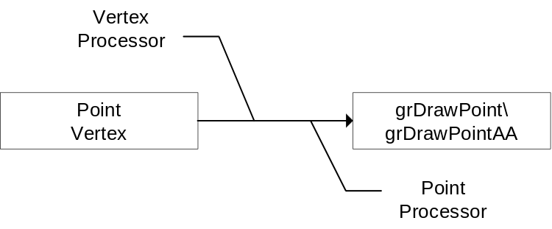

Triangle Mesh ( a triangle strip is a degenerate triangle mesh )
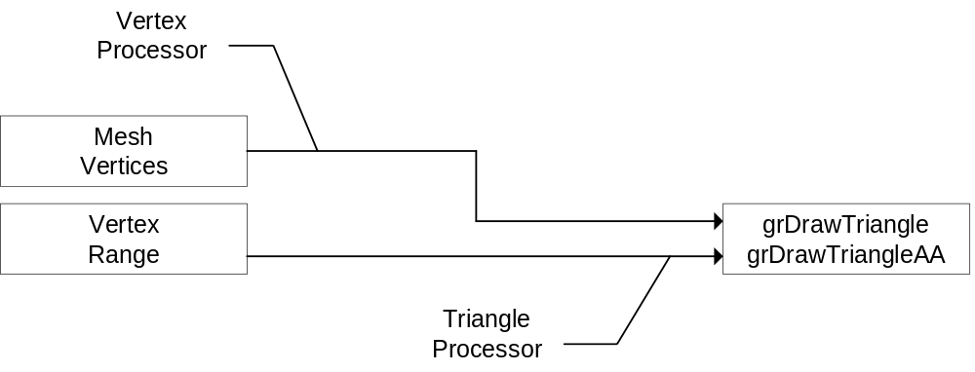

Line Mesh
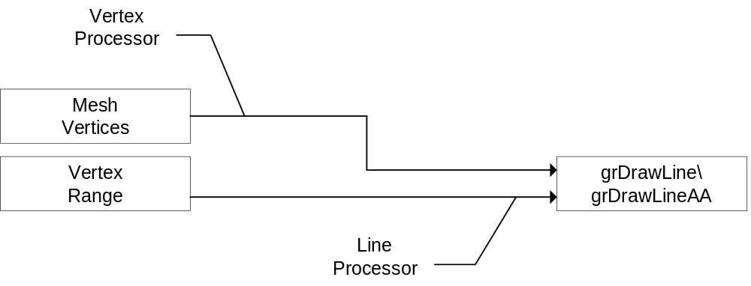

Pentium Cache Utilization

I am operating under the principle that if I can minimize the impact of L1 cache misses by carefully organizing all of the multiply referenced data necessary to my rendering code so that there will be no collisions between them. Half of the stack is devoted to such data, the other half ( or the second set of each cache line ) is expected to be utilized for input data and the stack.

Inner Loop Data

The LCStoCCS Transformation
AtrTransform LCStoCCS;
48 Bytes

The CCStoVCS Transformation
float xScale, yScale, xOffset, yOffset;
16 Bytes

Lighting/Culling Data
AtrVector3 cameraPositionInLCS;
AtrVector3 materialLightCache;
24 Bytes

Clipping Data
float nearClip, farClip;
8 Bytes

State Data
FxU32 currentMaterialFlags;
4 Bytes

Temporary GrVertices
Four GrVertices are kept and stuffed for calls to grDrawTriangle(), and eventually grDrawQuad(). The GrVertex structure is something like 48bytes as of this writing, will be padded out to 64 bytes when declared.
256 Bytes

Destination Vertices
These take up the remaining cache area. They are each 64 bytes in length.

Actual Cache Layout
Memory Offset | Data
0x000 | LCStoCCS
0x020 | LCStoCCS/CCStoVCS
0x040 | Lighting-Culling/Clipping Data
0x060 | State Data
0x080 | GrVertex0
0x0A0 | GrVertex0
0x0C0 | GrVertex1
0x0E0 | GrVertex1
0x100 | GrVertex2
0x120 | GrVertex2
0x140 | GrVertex3
0x160 | GrVertex3
0x180 -> 0xFE0 | AtrDestVertices(58)

Triangle And Quad Setup
Triangle setup is handled by Glide. As of this writing, Glide does not support efficient Quad setup. If this has not changed before it is necessary to implement Quads in ATR, I will implement the Quad setup code myself and submit it for addition into Glide.

Vertex Data Structures
A great deal of the computation in the graphics pipeline centers around per-vertex data. Therefore, the vertex data structure deserves special attention.

Input Vertices

Are arranged so that the most common data for a vertex falls on the first cache line.

Three sets of textures coordinates are stored here in anticipation of the requirements of high quality multi-pass texture mapping operation( or multiple TMU ops ).

 | 0x0 | 0x4 | 0x8 | 0xC | 0x10 | 0x14 | 0x18 | 0x1C
Line n | X | Y | Z | I | J | K | S0 | T0
Line n+1 | R | G | B | A | S1 | T1 | S2 | T2

Output Vertices

This layout optimizes for the ITRG triangle case, whether moving the first set of texture coordinates improves the performance of more mainstream texture mapping applications is cause for deliberation.

Can be specialized further, but for the time being will be left in this general format. Specializing the vertices to particular rendering applications will give some performance gains, but would add significant complexity to the renderer at this early stage of design.

 | 0x0 | 0x4 | 0x8 | 0xC | 0x10 | 0x14 | 0x18 | 0x1C
Line n | X | Y | OOW | R | G | B | A | FLAG
Line n+1 | S0 | T0 | S1 | T1 | S2 | T2 | - | -

Primitive Data Structures

Quad Set
A Quad Set derives some of its performance from a careful sorting and partitioning of vertices so that they may be processed in cacheable chunks. Therefore a Quad Set is slightly more complex than a simple list of vertices and connectivity. A functional interface is provided to build quad sets from input vertices. A Quad Set contains the following members:

struct AtrQuadSet {
FxU32 numVertices;
InputVertex *vertices;
FxU32 *connectivity;
struct AtrQuadSet *next;
};

numVertices - total number of vertices in this chunk
vertices - list of vertices for this chunk
connectivity - connectivity is an array of longs that indexes into the vertex list for this chunk. a connectivity entry of 0x0 indicates the end of processing for the current chunk.
next - pointer to next chunk in this set Null when set is finished.

When rendering a Quad Set the data is processed as follows:
AtrQuadSet *chunk = quadSet;
while( chunk ) {
FxU32 *quad = chunk->connectivity;
for ( vertex = 0; vertex < numVertices; vertex++ ) {
processVertex( vertexCache[vertex], chunk->vertices[vertex] );
}
while( *quad ) {
if ( quad passes clip test ) {
COPY_VERTEX( vertex0, vertexCache[VERTEX0(quad)] );
COPY_VERTEX( vertex1, vertexCache[VERTEX1(quad)] );
COPY_VERTEX( vertex2, vertexCache[VERTEX2(quad)] );
grDrawTriangle( vertex0, vertex1, vertex2 );
COPY_VERTEX( vertex2, vertexCache[VERTEX3(quad)] );
grDrawTriangle( vertex0, vertex1, vertex2 );
} else {
OutputVertex inverts[4];
inverts[0] = vertexCache[VERTEX0(quad)];
inverts[1] = vertexCache[VERTEX1(quad)];
inverts[2] = vertexCache[VERTEX2(quad)];
inverts[3] = vertexCache[VERTEX3(quad)];
clipAndRender( 4, inverts );
}
chunk = chunk->next;
}

Triangle Set
A Triangle Set derives some of its performance from a careful sorting and partitioning of vertices so that they may be processed in cacheable chunks. Therefore a Triangle Set is slightly more complex than a simple list of vertices and connectivity. A functional interface is provided to build Triangle sets from input vertices. A Triangle Set contains the following members:

struct AtrTriangleSet {
FxU32 numVertices;
InputVertex *vertices;
FxU32 *connectivity;
struct AtrTriangleSet *next;
};

numVertices - total number of vertices in this chunk
vertices - list of vertices for this chunk
connectivity - connectivity is an array of longs that indexes into the vertex list for this chunk. a connectivity entry of 0x0 indicates the end of processing for the current chunk.
next - pointer to next chunk in this set Null when set is finished.

When rendering a Triangle Set the data is processed as follows:
AtrTriangleSet *chunk = TriangleSet;
while( chunk ) {
FxU32 *triangle = chunk->connectivity;
for ( vertex = 0; vertex < numVertices; vertex++ ) {
processVertex( vertexCache[vertex], chunk->vertices[vertex] );
}
while( *triangle ) {
if ( triangle passes clip test ) {
COPY_VERTEX( vertex0, vertexCache[VERTEX0(Triangle)] );
COPY_VERTEX( vertex1, vertexCache[VERTEX1(Triangle)] );
COPY_VERTEX( vertex2, vertexCache[VERTEX2(Triangle)] );
grDrawTriangle( vertex0, vertex1, vertex2 );
} else {
OutputVertex inverts[3];
inverts[0] = vertexCache[VERTEX0(Triangle)];
inverts[1] = vertexCache[VERTEX1(Triangle)];
inverts[2] = vertexCache[VERTEX2(Triangle)];
clipAndRender( 3, inverts );
}
chunk = chunk->next;
}

Line Set
A Line Set derives some of its performance from a careful sorting and partitioning of vertices so that they may be processed in cacheable chunks. Therefore a Line Set is slightly more complex than a simple list of vertices and connectivity. A functional interface is provided to build line sets from input vertices. A Line Set contains the following members:

struct AtrLineSet {
FxU32 numVertices;
InputVertex *vertices;
FxU32 *connectivity;
struct AtrLineSet *next;
};

numVertices - total number of vertices in this chunk
vertices - list of vertices for this chunk
connectivity - connectivity is an array of longs that indexes into the vertex list for this chunk. a connectivity entry of 0x0 indicates the end of processing for the current chunk. For lines the connectivity Word is actually two line segments set out <start><end><start><end>
next - pointer to next chunk in this set. Null when set is finished.

When rendering a Line Set the data is processed as follows:
AtrLineSet *chunk = LineSet;
while( chunk ) {
FxU32 *lines = chunk->connectivity;
for ( vertex = 0; vertex < numVertices; vertex++ ) {
processVertex( vertexCache[vertex], chunk->vertices[vertex] );
}
while( *lines ) {
if ( line passes clip test ) {
COPY_VERTEX( vertex0, vertexCache[VERTEX0(lines)] );
COPY_VERTEX( vertex1, vertexCache[VERTEX1(lines)] );
grDrawLine( vertex0, vertex1 );
COPY_VERTEX( vertex0, vertexCache[VERTEX2(lines)] );
COPY_VERTEX( vertex1, vertexCache[VERTEX3(lines)] );
grDrawLine( vertex0, vertex1 );
}
}
chunk = chunk->next;
}

Point Set
A Point Set simply transforms and renders vertices as quickly as possible. It still uses chunks so that it may take advantage of pre-fetching to speed up rendering.
A Point Set contains the following members:
struct AtrPointSet {
FxU32 numVertices;
InputVertex *vertices;
struct AtrLineSet *next;
};

numVertices - total number of vertices in this chunk
vertices - list of vertices for this chunk
next - pointer to next chunk in this set. Null when set is finished.
When rendering a Point Set the data is processed as follows:
AtrPointSet *chunk = pointSet;
while( chunk ) {
for ( vertex = 0; vertex < numVertices; vertex++ ) {
processVertex( vertexCache[vertex], chunk->vertices[vertex] );
COPY_VERTEX( vertex0, vertexCache[vertex] );
grDrawPoint( vertex0 );
}
chunk = chunk->next;
}

Triangle Mesh
A Triangle Mesh is a set of triangles derived from a regular MxN rectangular( or perturbed-rectangular ) grid of vertices where the connectivity of the triangles is implicit.
A Triangle Mesh contains the following members:
struct AtrTriangleMesh {
FxU32 m;
FxU32 n;
InputVertex *vertices;
};

m - width of mesh
n - height of mesh
vertices - pointer to list of vertices in row-first order from upper left to bottom right corner of mesh
When rendering a Triangle Mesh the data is processed as follows:

/* Note, this code won’t actually work */
AtrTriangleMesh *mesh = thisMesh;
for( n = 0; n < mesh->n - 1; n++ ) {
/* First Tri */
processVertex( vertexCache[0], mesh->vertices[n][0] );
processVertex( vertexCache[1], mesh->vertices[n+1][0] );
COPY_VERTEX( vertex0, vertexCache[0] );
COPY_VERTEX( vertex1, vertexCache[1] );
for( m = 1; m < mesh->m - 1; m++ ) {
processVertex( vertexCache[2], mesh->vertices[n][m] );
COPY_VERTEX( vertex2, vertexCache[2] );
grDrawTriangle( vertex0, vertex1, vertex2 );
processVertex( vertexCache[0], mesh->vertices[n+1][m] );
COPY_VERTEX( vertex0, vertexCache[0] );
grDrawTriangle( vertex0, vertex1, vertex2 );
}
}

Line Mesh
A Line Mesh is a set of triangles derived from a regular MxN rectangular( or perturbed-rectangular ) grid of vertices where the connectivity of the lines is implicit.
A Line Mesh contains the following members:
struct AtrLineMesh {
FxU32 m;
FxU32 n;
InputVertex *vertices;
};

m - width of mesh
n - height of mesh
vertices - pointer to list of vertices in row-first order from upper left to bottom right corner of mesh

Immediate Quad, Triangle, Line, Point
The interface to all immediate primitives is structureless above the level of an input vertex.

Immediate Primitive Rendering

Texture Cache
As it stands, the texture cache is significantly bound by limitations of Glide’s exposure of texture memory. If a suitable hole is unavailable to ATR to download a texture, then the entire texture memory must be invalidated.

Bounding Box Computation

Geometric Morphing Support

Intra-Object BSP’s

Generation

Traversal

Static Lighting Generation

Billboards

Material Properties and Feature Exposure

